**JENKINS-POC**

**Launch EC2 instance with t2.medium instance type**

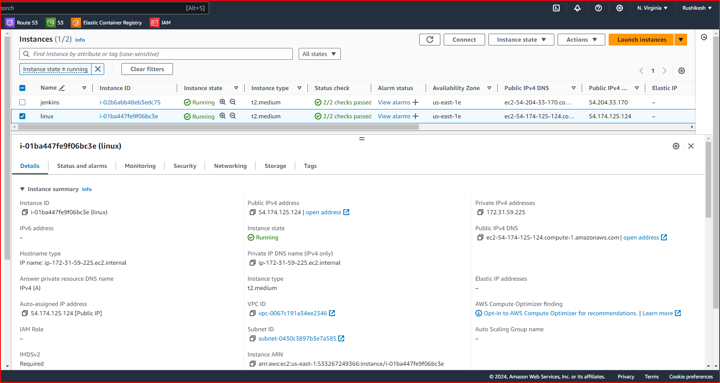

**Connect to EC2 instance**

**sudo yum update -y**

**sudo yum install python3-pip -y**

**pip3 --version**

**pip3 install Flask**

**python3 -m flask --version**

**sudo yum install docker.io**

**sudo yum install docker -y**

**sudo systemctl start docker**

**docker run -d --name jenkinscontainer -p 80:8080 jenkins/jenkins**

**docker ps -a**

**docker ps**

**docker exec -it 0579 bash**

**git clone https://github.com/rushikeshmj/hello-world.git**

**cd hello-world/**

**pwd**

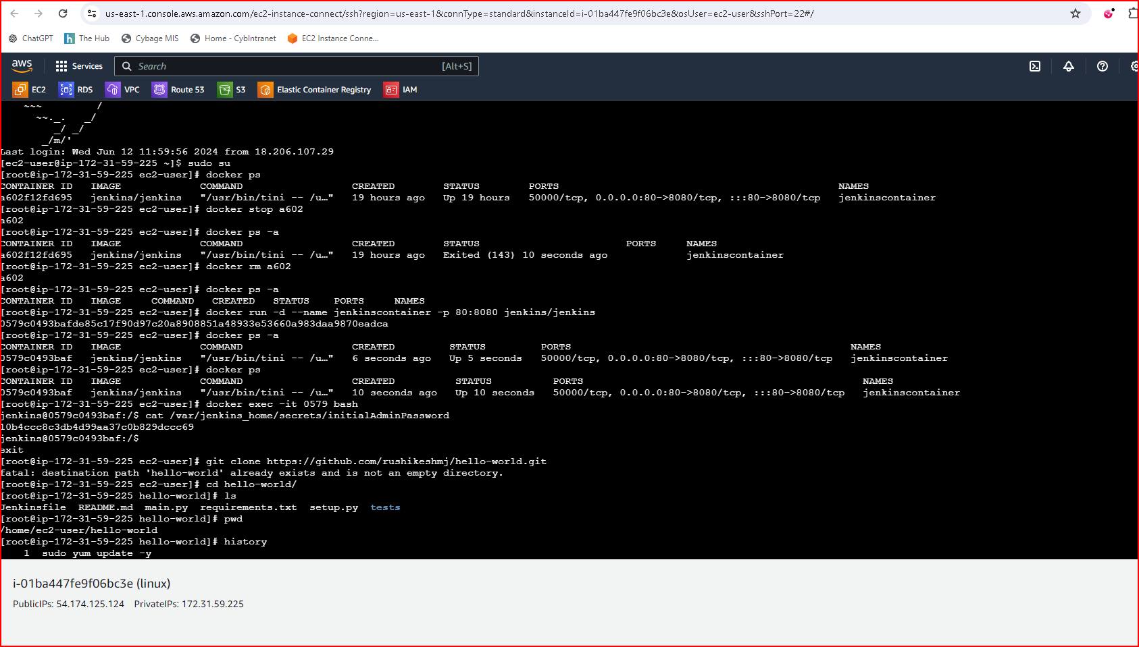

**Install plugins**

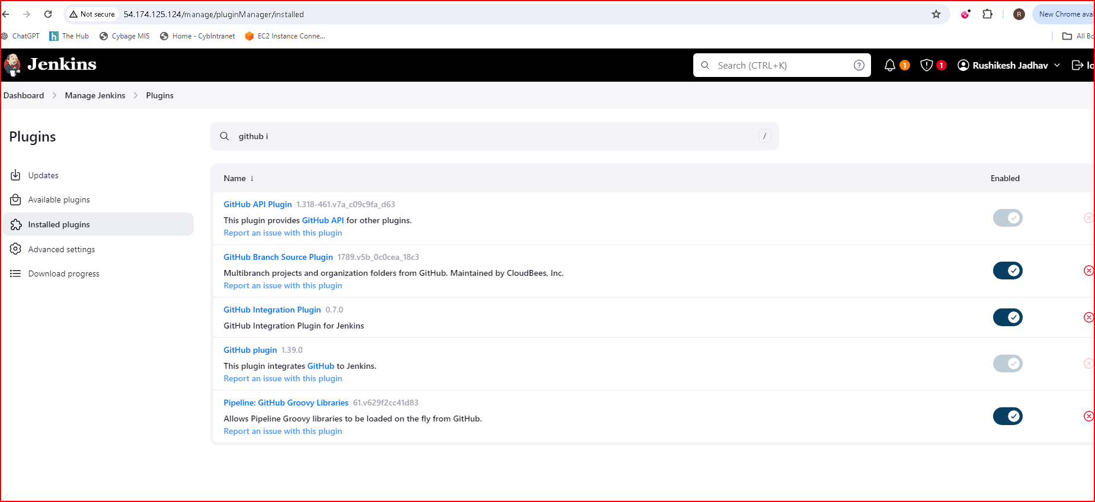



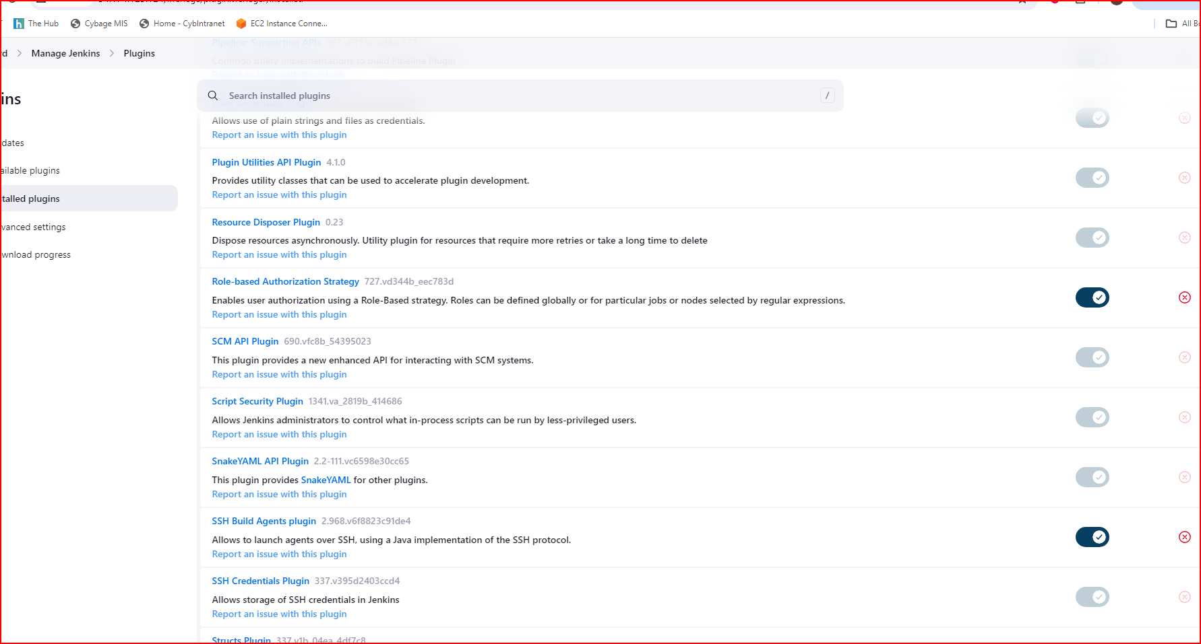

**Add credentials**

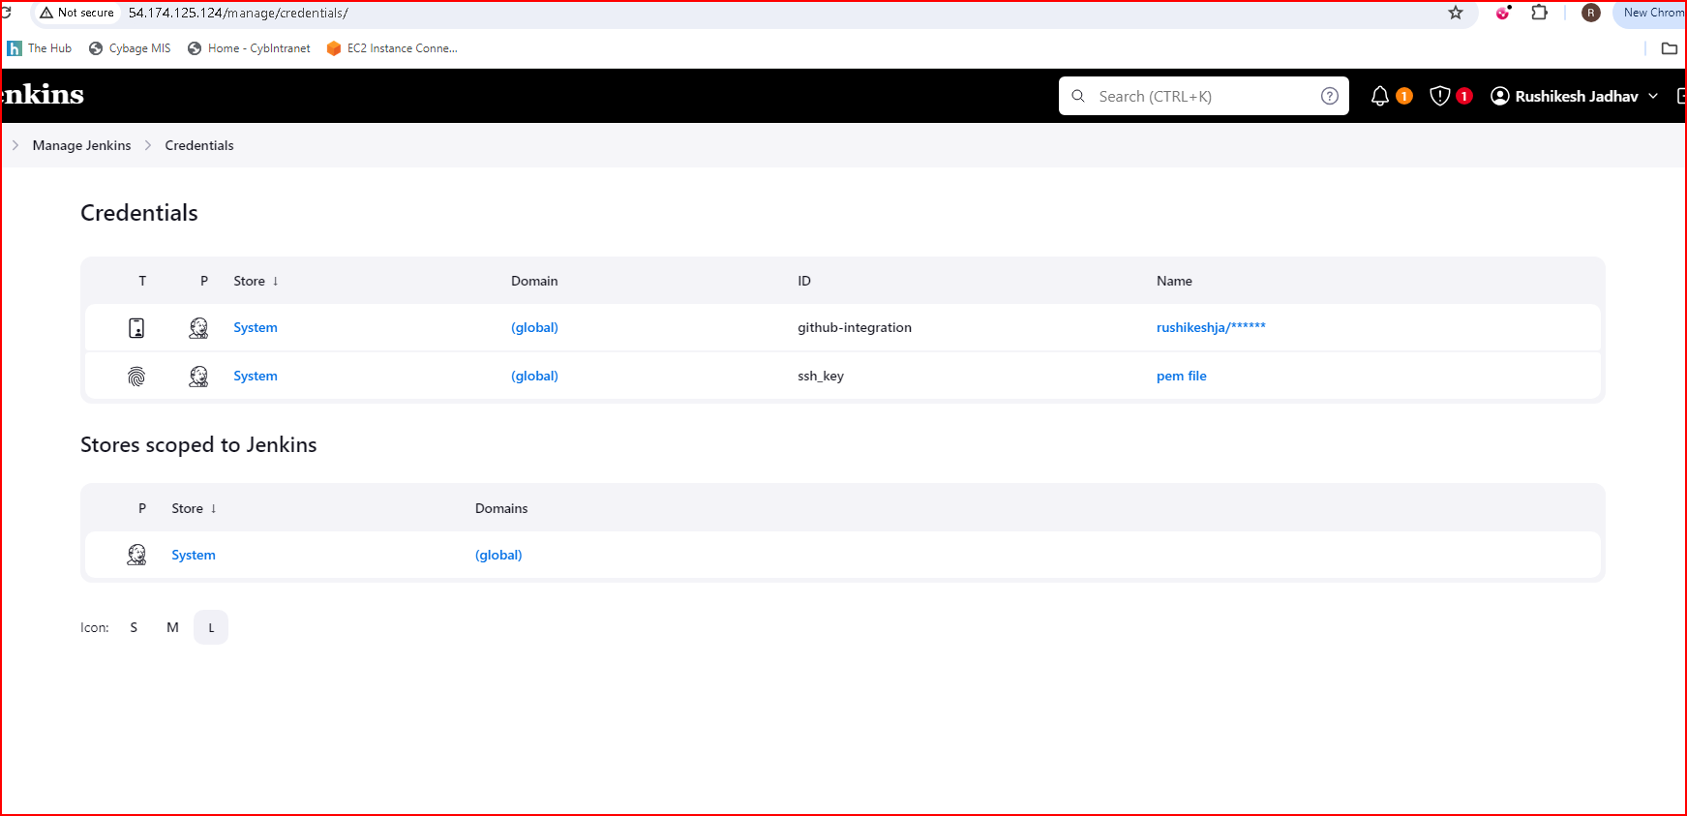

**Create sample repository in github**

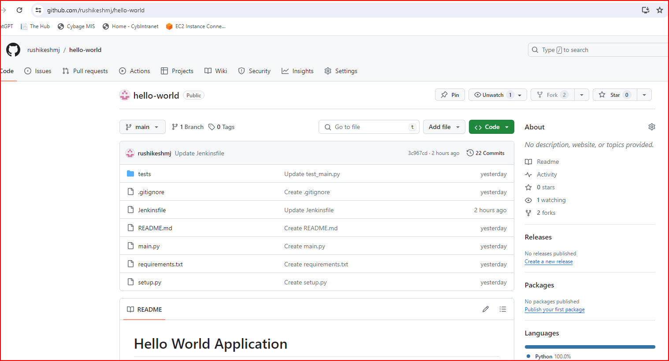

**Create Jenkins file in that repo**

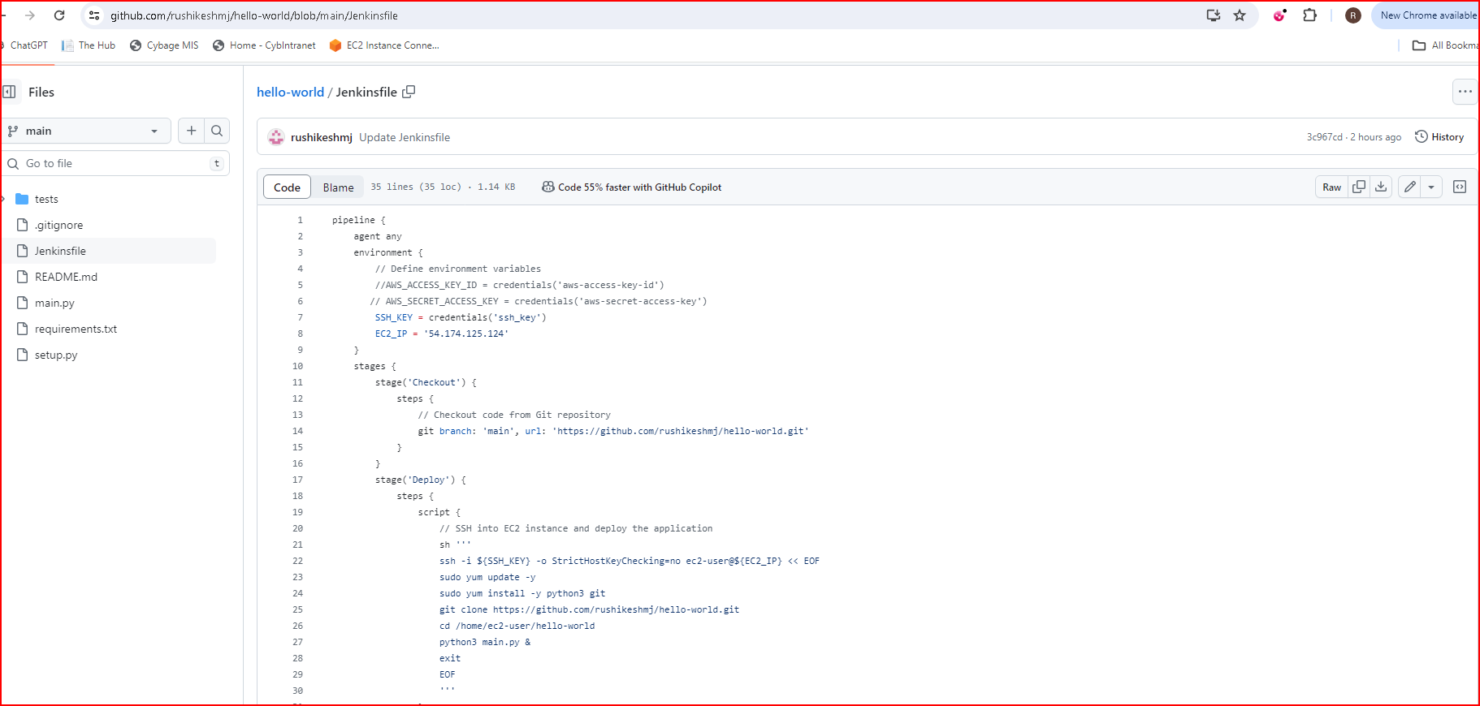

**Configure the github repo and cred in configure section**

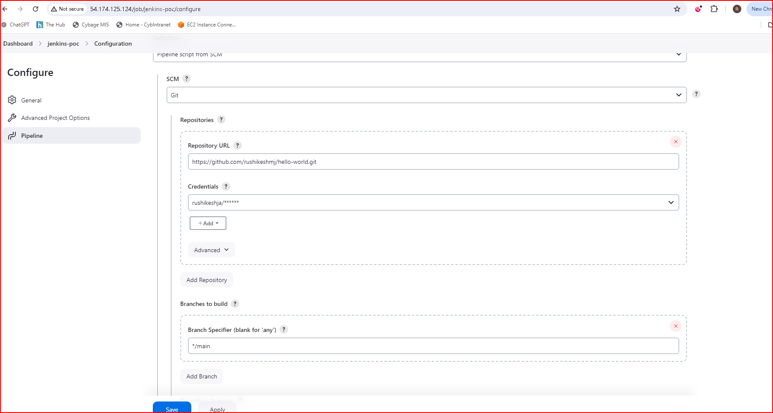

**Click on build now and the console output**

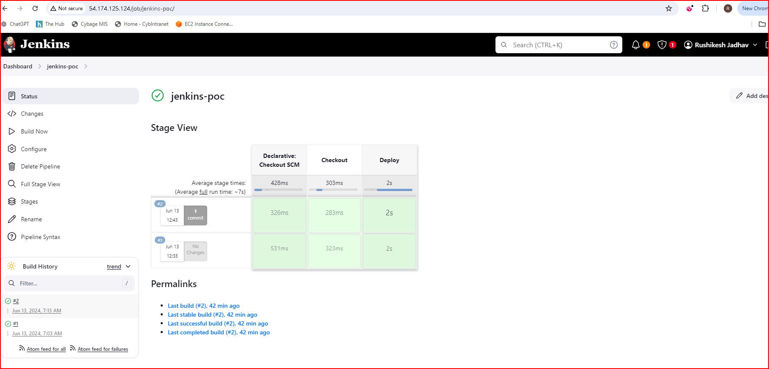

**Check the console output**

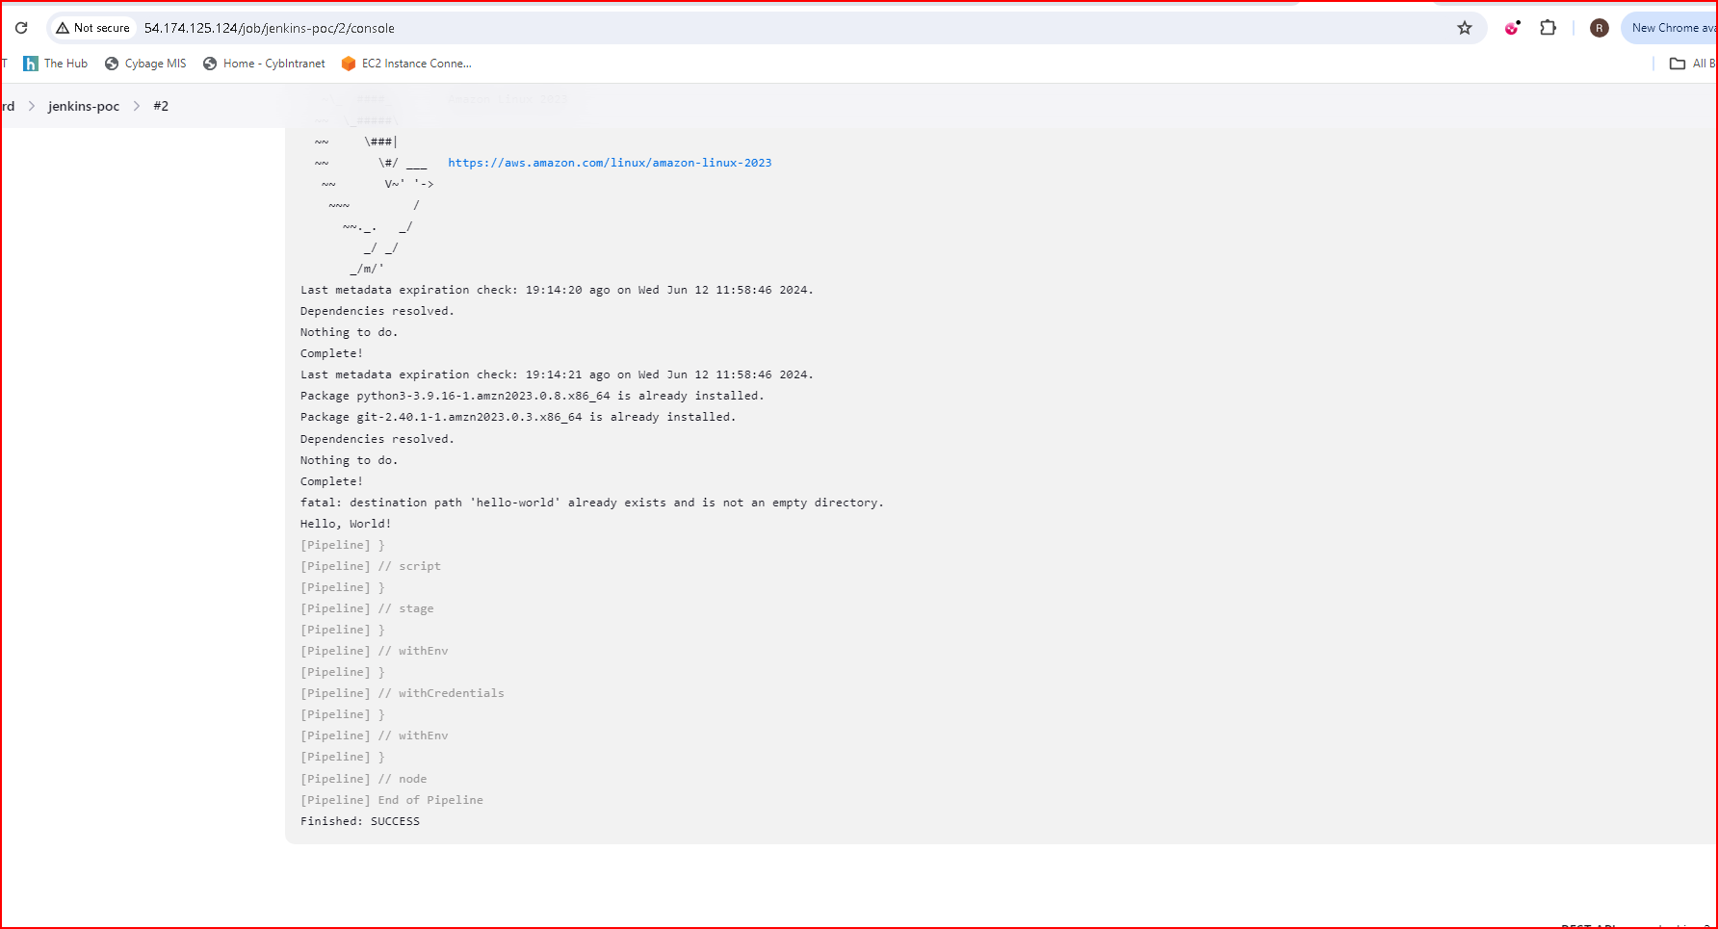

**Use role-based strategy in Authorization**

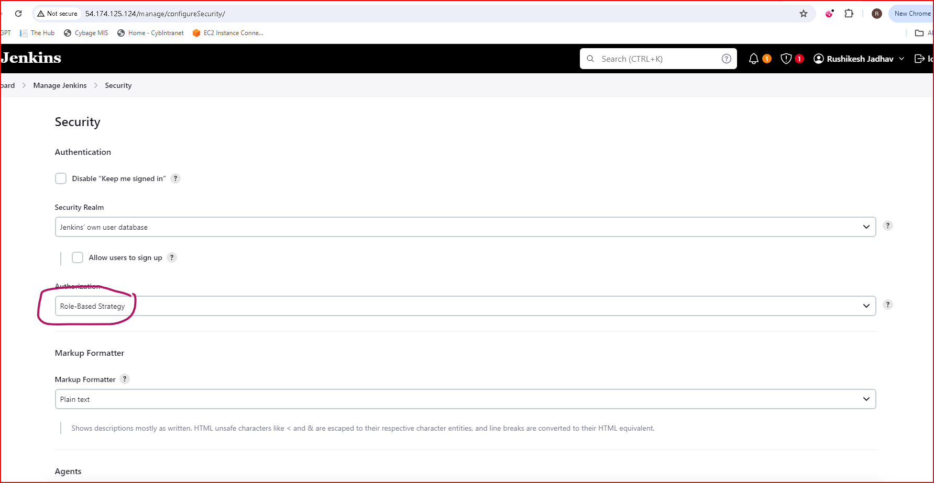

**Create 5 users**

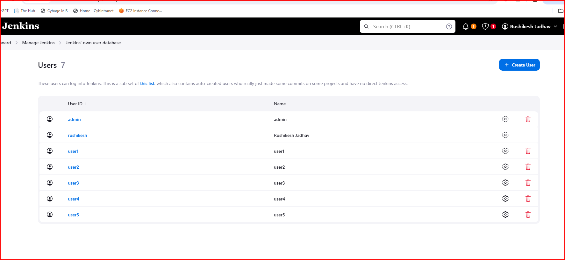

**Create 5 jobs**

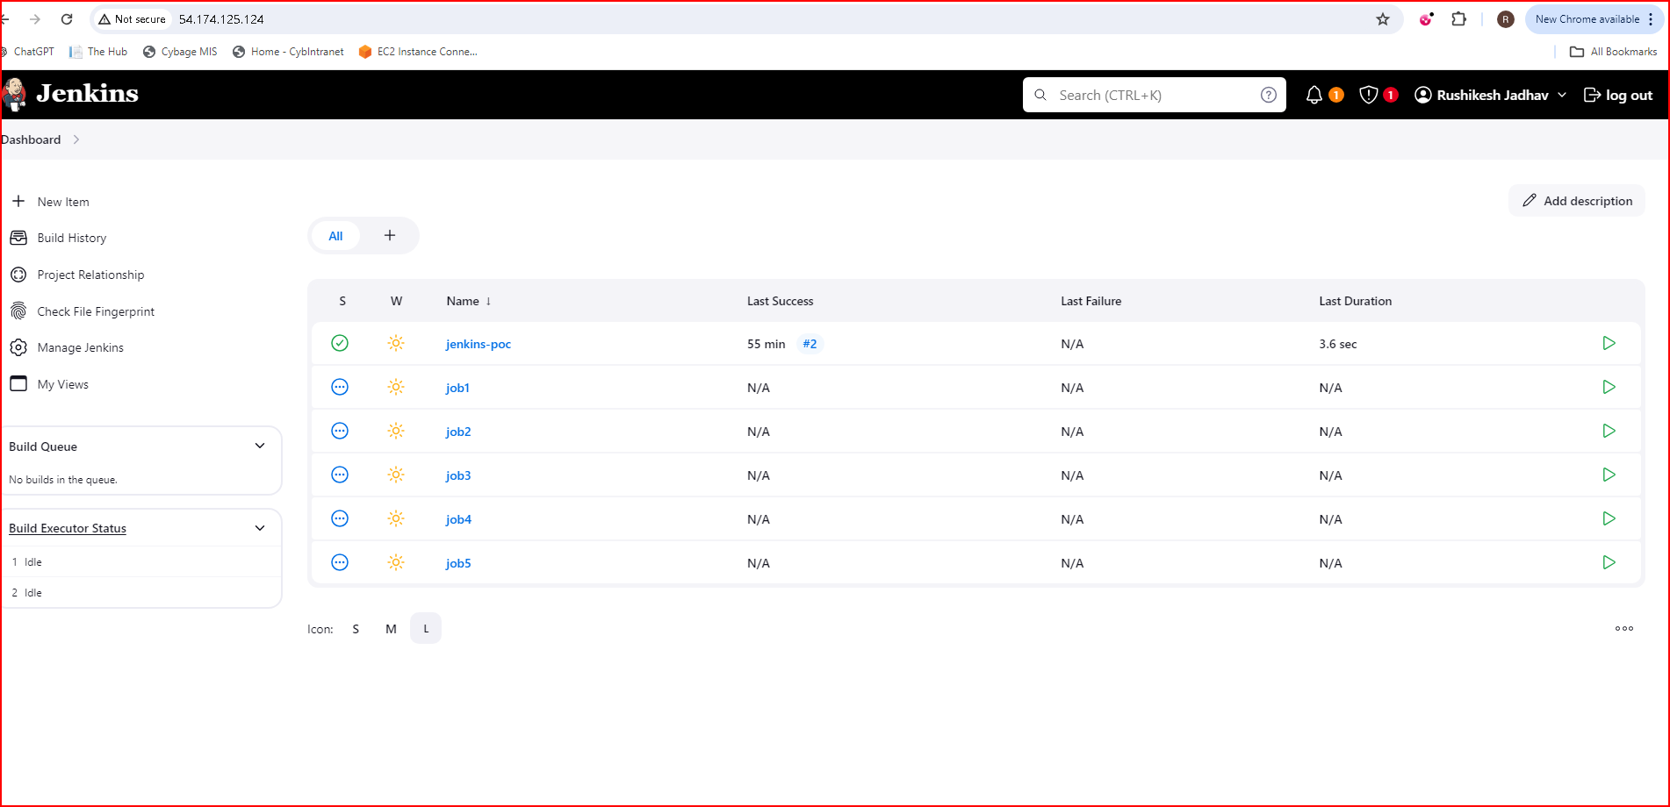

**User1 cannot create Job**

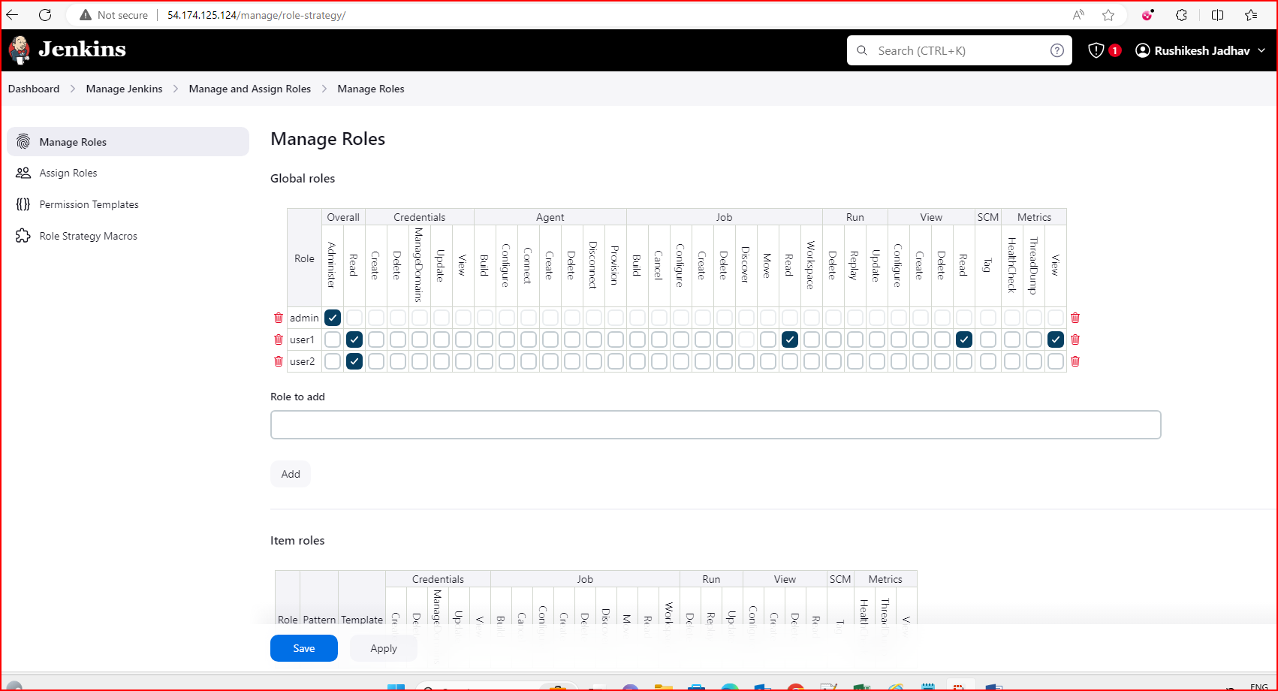

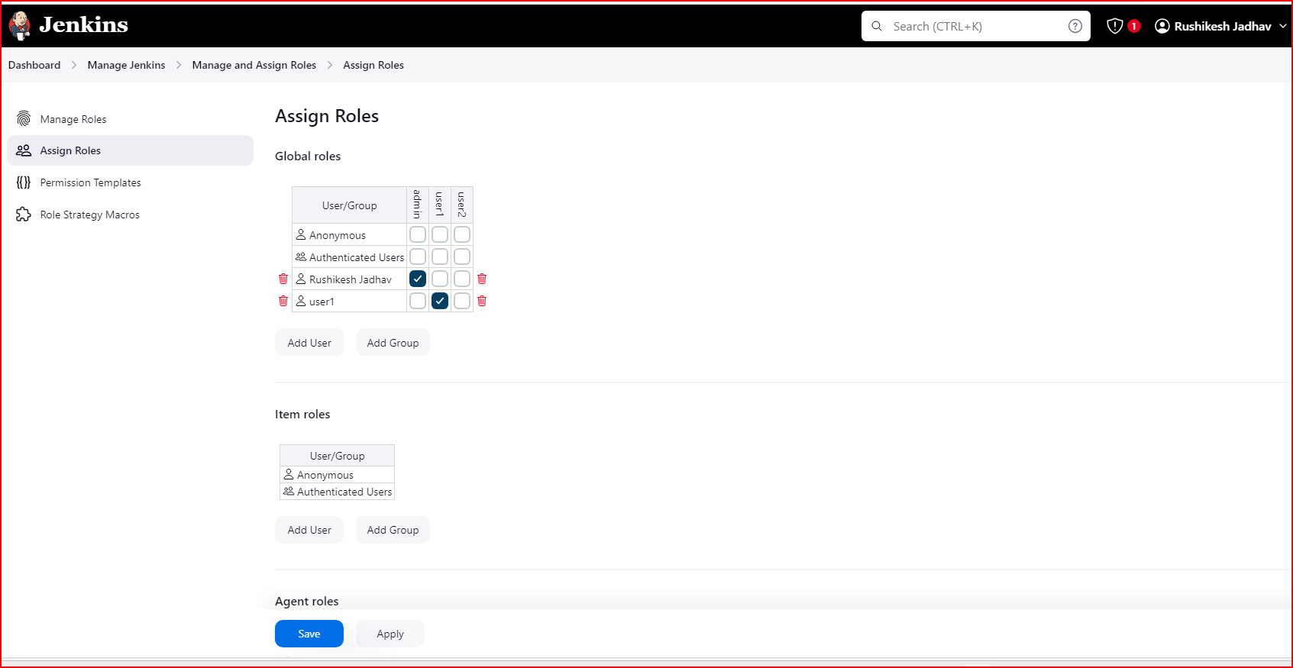

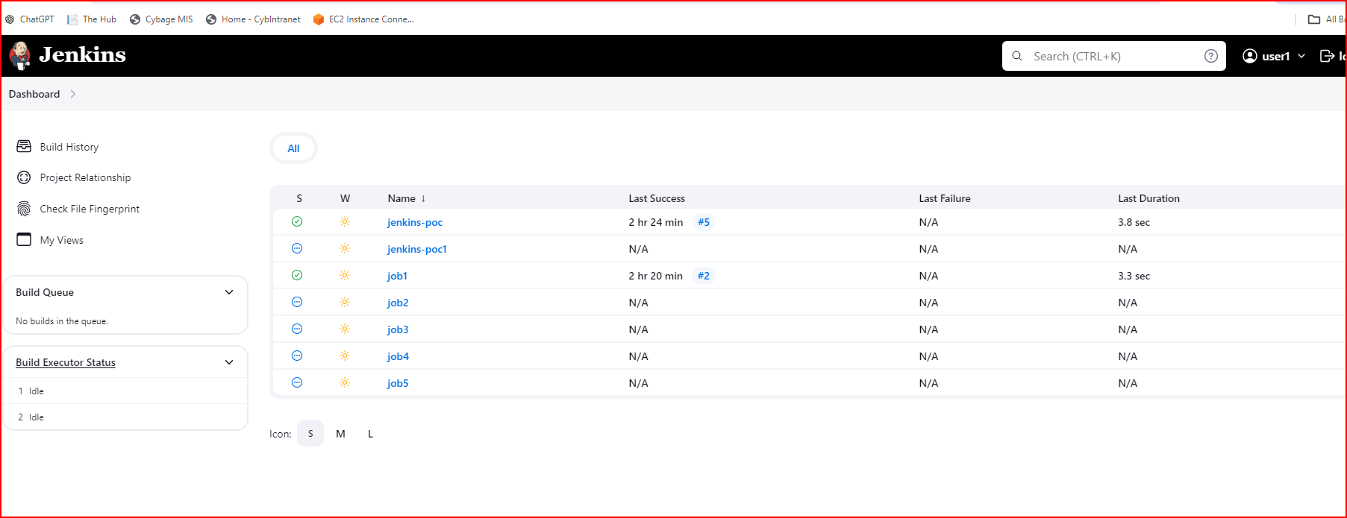

**User2 cannot run the Job**

